Using Groups in LMS
LMS groups can be used when:
- You are a teacher in a course where you have several classes and you want to filter your activities and gradebook so you only see one class at a time.
- You want to allocate a particular activity, resource or topic section to just one class or set of users and you don’t want others to see it.
A group or grouping can be used at two levels:
- Course level - The group mode defined at the course level is the default mode for all activities defined within that course. To use groups you need first to set a group mode through Course > Edit settings.
- Click on the “Actions Menu” icon available in the top right of the course page. Click on the link “Edit Settings” from the dropdown menu.

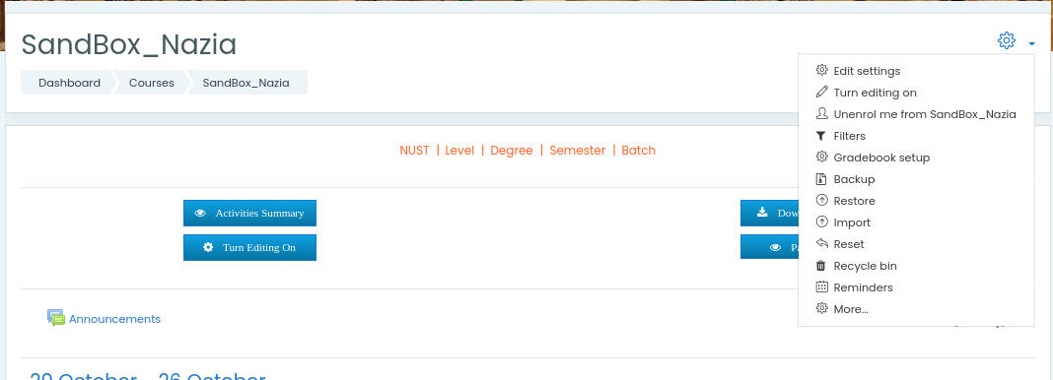

  - Enable course level group settings if you want to apply group mode to all activities of the course, otherwise you may choose group mode in the settings of individual activities.

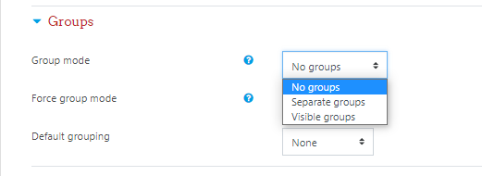

- Activity level - Each activity that supports groups can also have its own group mode defined. If the course setting "Force group mode" is set to "Yes" then the option to define the group mode for individual activities is not available. If it is set to "No", then the teacher may change the group mode within activities.

1. Creating a Group

- Click on the “Actions Menu” icon available in the top right of the course page. Click on the link “More” from the dropdown menu.

- Select the “Users” tab and click on the link “Groups”.

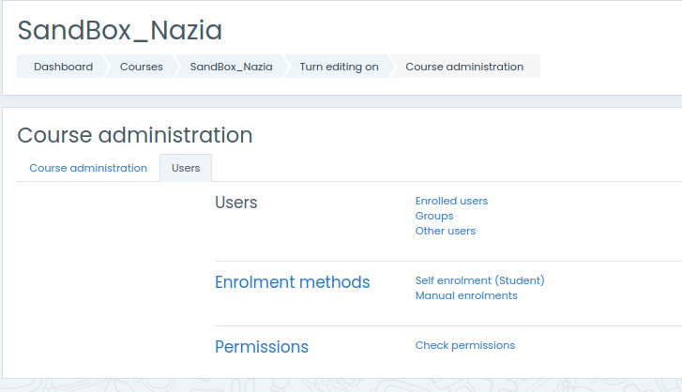

New group creation and the existing groups’ editing and deletion can be done using this interface.

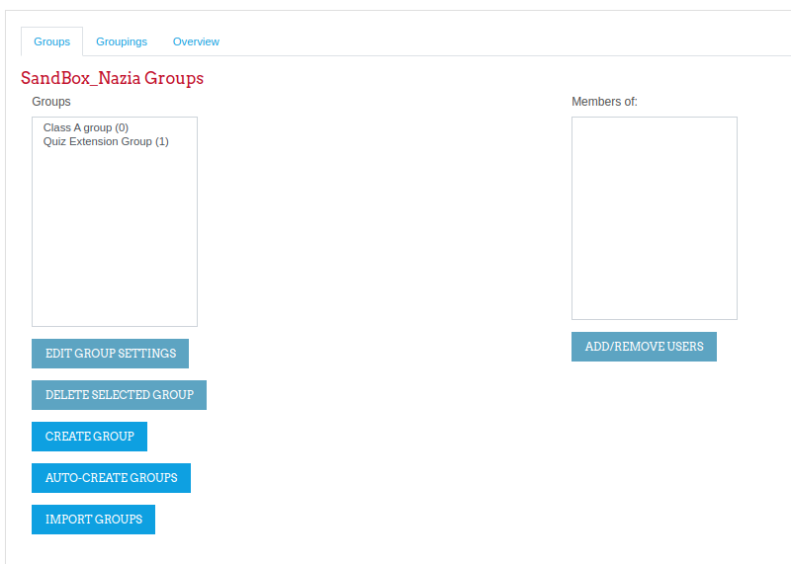

- For a new group creation, click on the “Create group”, add a group name and its optional description in respective fields.

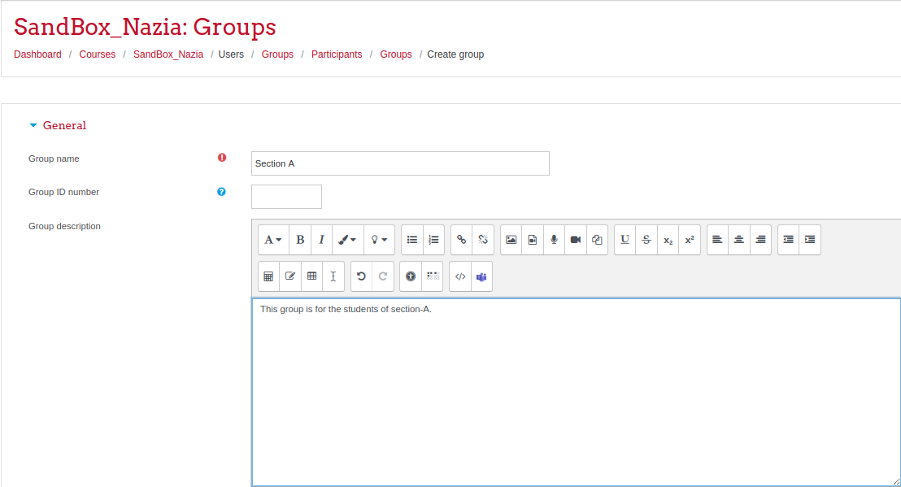

- Enable group messaging if you wish to engage in group conversations. You will then be able to send group messages from the messaging drawer. Click the 'Save changes' button.

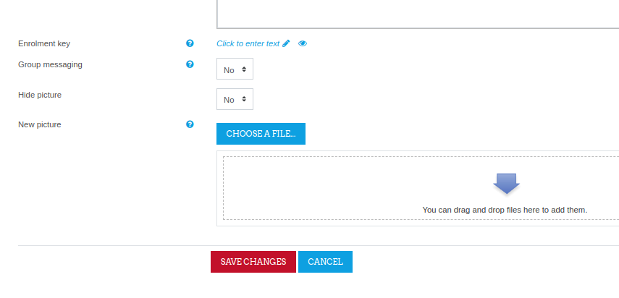

- Select the group to which you want to add participants, then click the 'Add/remove users button.

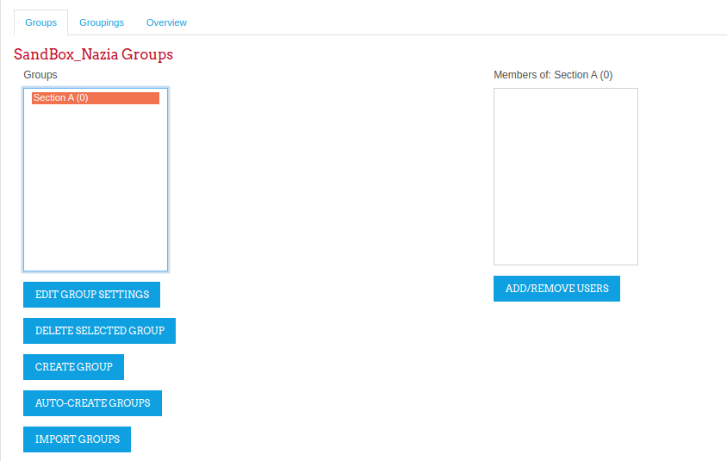

- In the "Potential members" list, select the users you want to add to the group. Multiple users may be selected using the Ctrl key. If the students list is too long for display, search the individual students using their names or registration numbers.

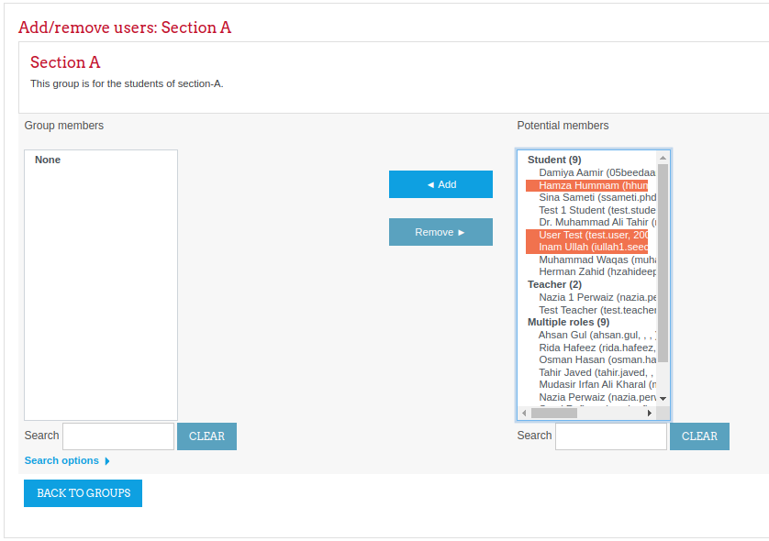

- Add the users to the selected group using the “Add” button.

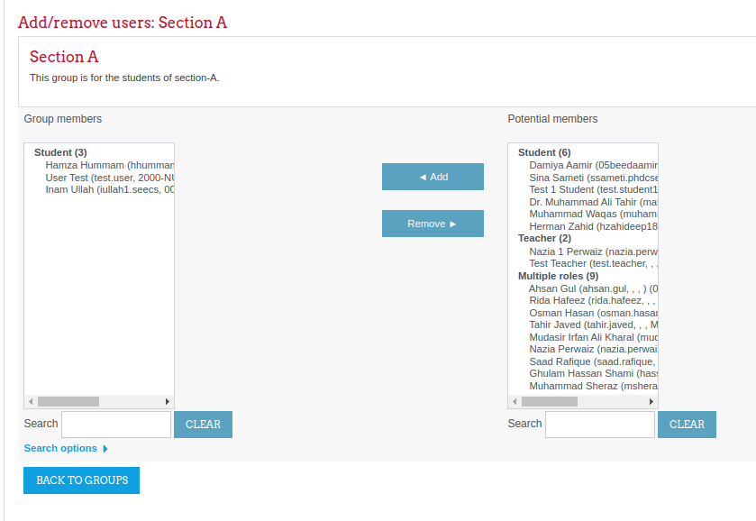

2. Groupings
A grouping is a collection of groups within a course. Using groupings allows you to direct tasks at one or more groups in your course, so that they can work together on the tasks.

Adding groups to grouping (Mandatory step)
- Click the “Groupings” tab.
- Create a new grouping by clicking the “Create grouping” button on the groupings page.

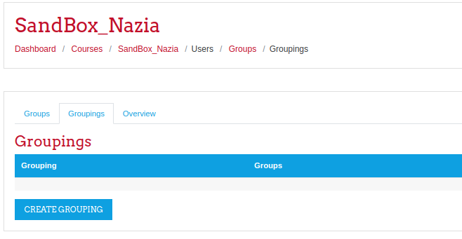
- Add grouping name and its description. (A grouping might contain single or multiple groups)

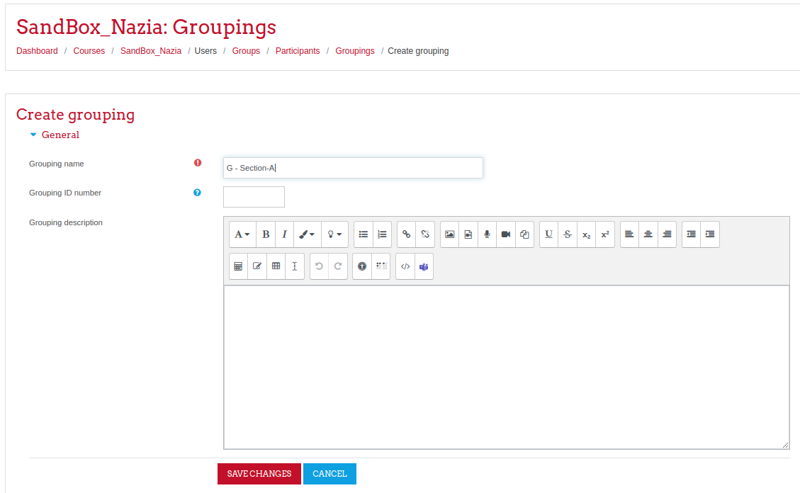

- Click on the “Show groups in grouping” icon (the rightmost icon in a particular row) to add groups into the selected grouping.
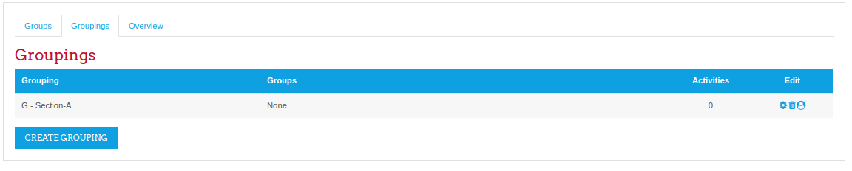
- All groups of the course will be listed in potential members. Select and add a group into the grouping. Multiple groups can be selected using the ctrl button.
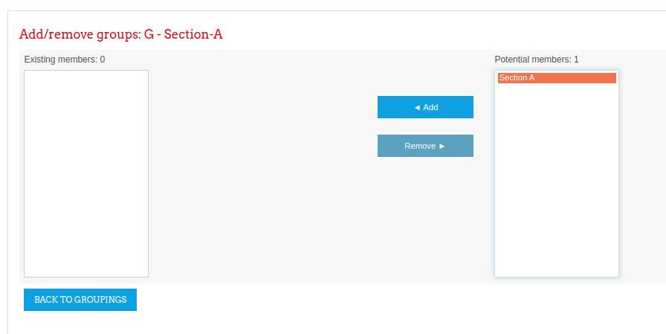

- Click on the button “Back to groupings”.

3. Apply groups/ grouping for an activity
To use a particular grouping in an activity:
- Click the 'Edit settings' link for the activity
- In the “Common module settings” section, set a group mode “Separate groups”
- Select the grouping from the grouping dropdown menu.

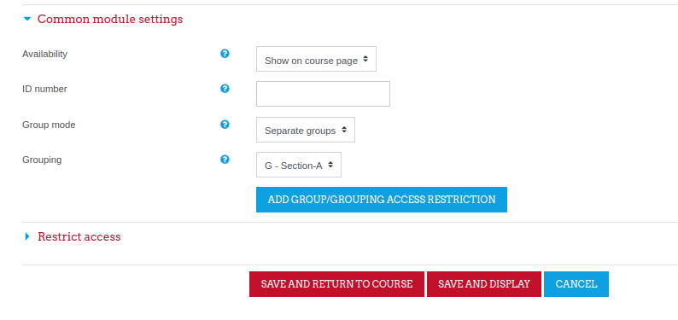
- Click the button “Add Group/ Grouping Access Restriction”. This will grey-out the button as shown in the following figure.
- Save the changes by clicking on “Save and return to course”.

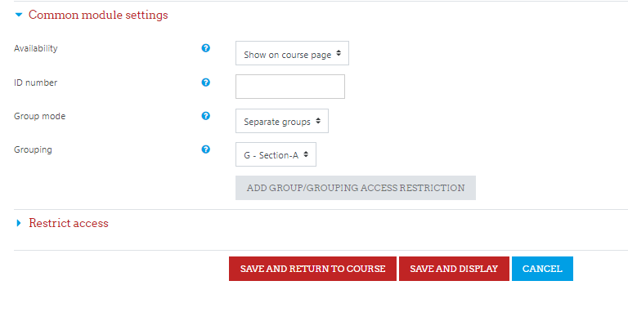

If the group mode is set to separate groups, students will only see the activities they have been assigned to. Teachers will see the name of the grouping in brackets after the activity name on the course page. A count of activities assigned to each grouping is kept on the groupings page.

_________________

